Deploy Jenkins on ubuntu machine

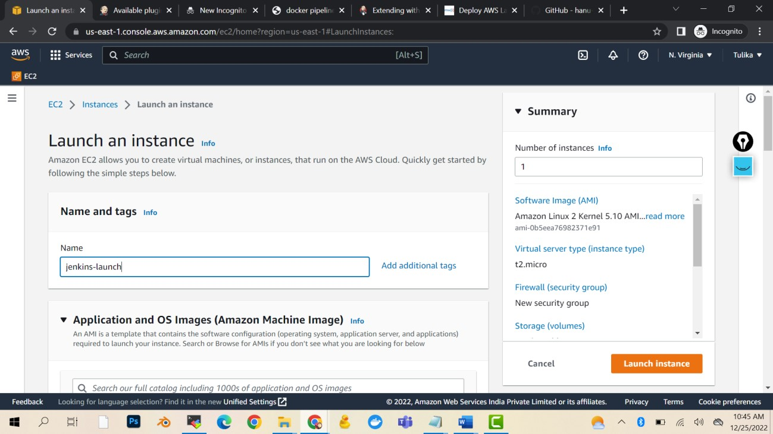

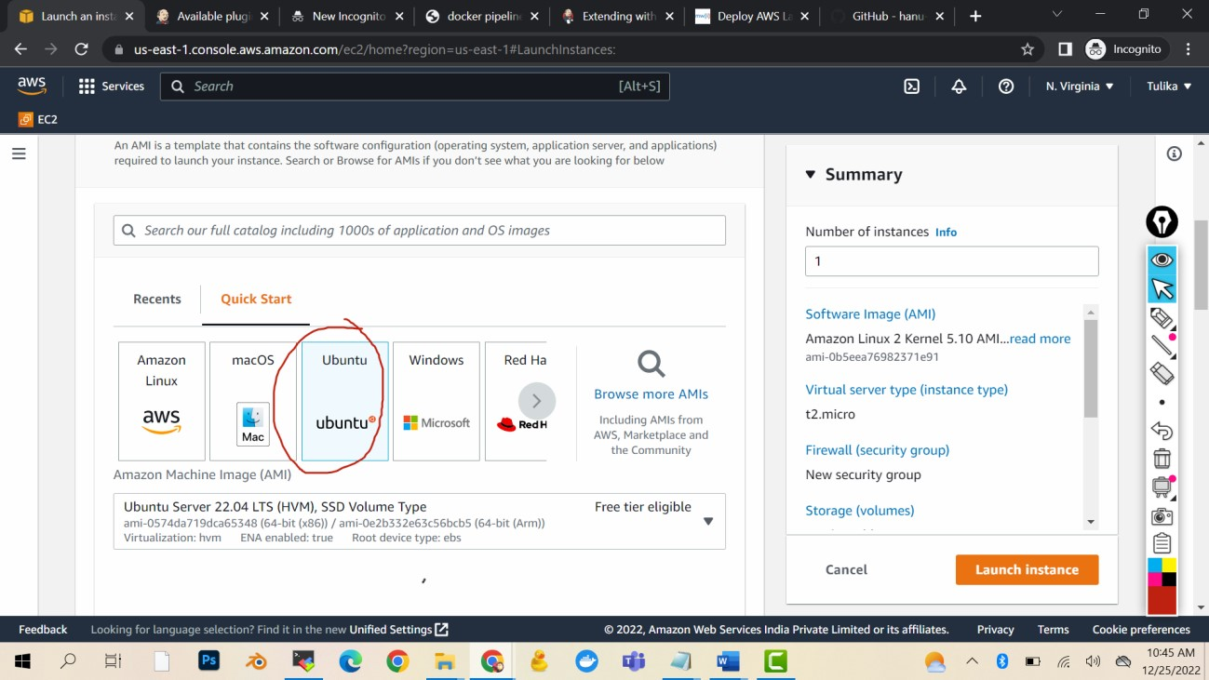

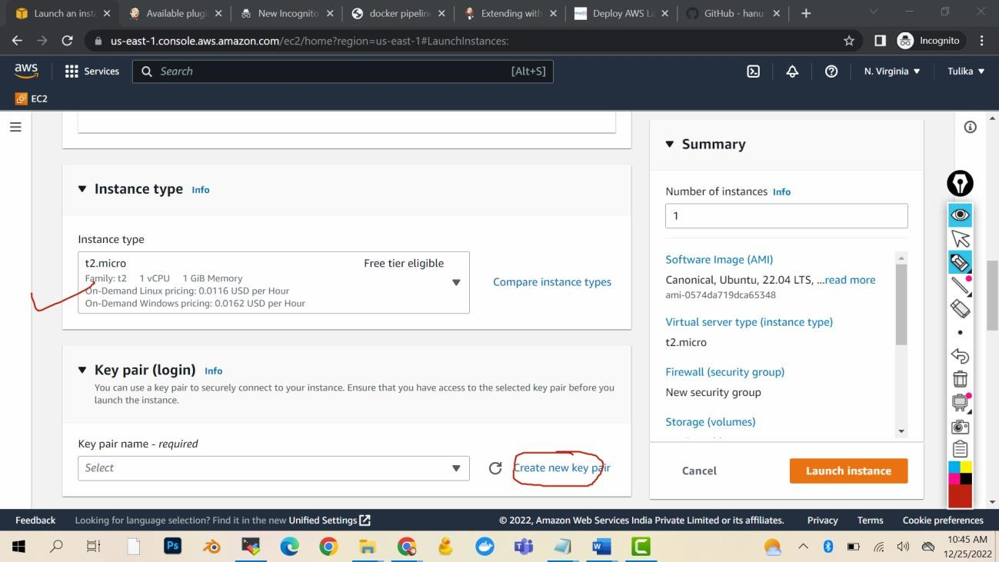

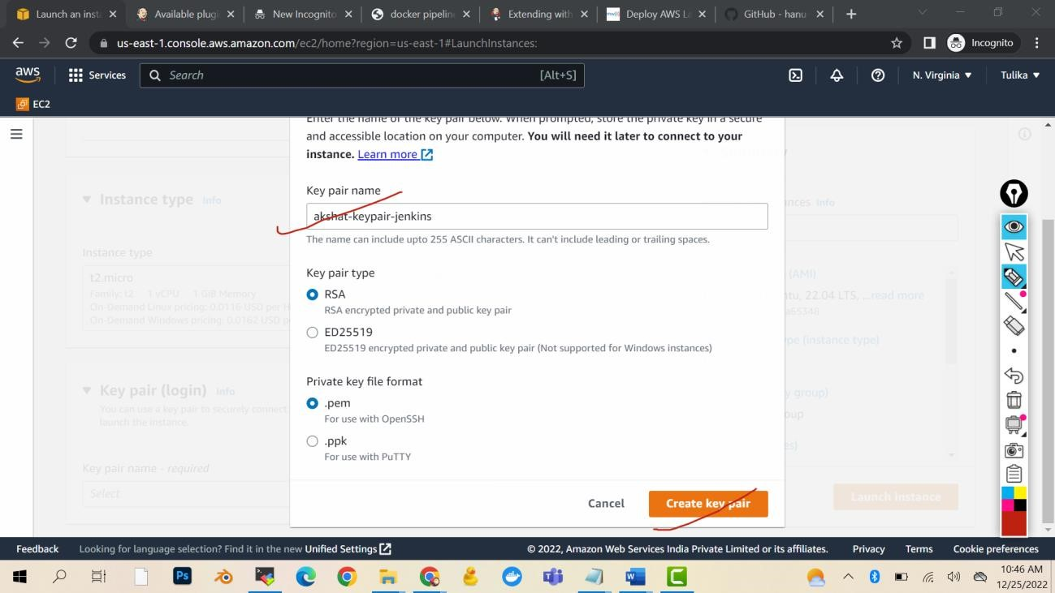

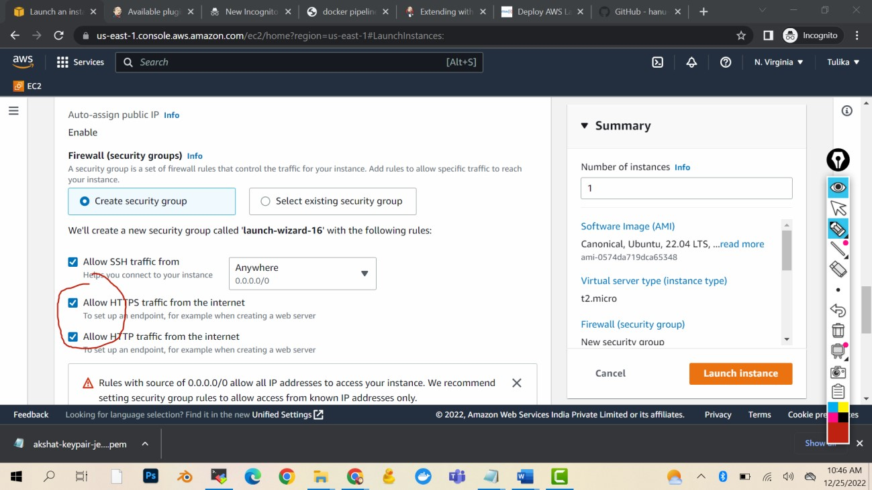

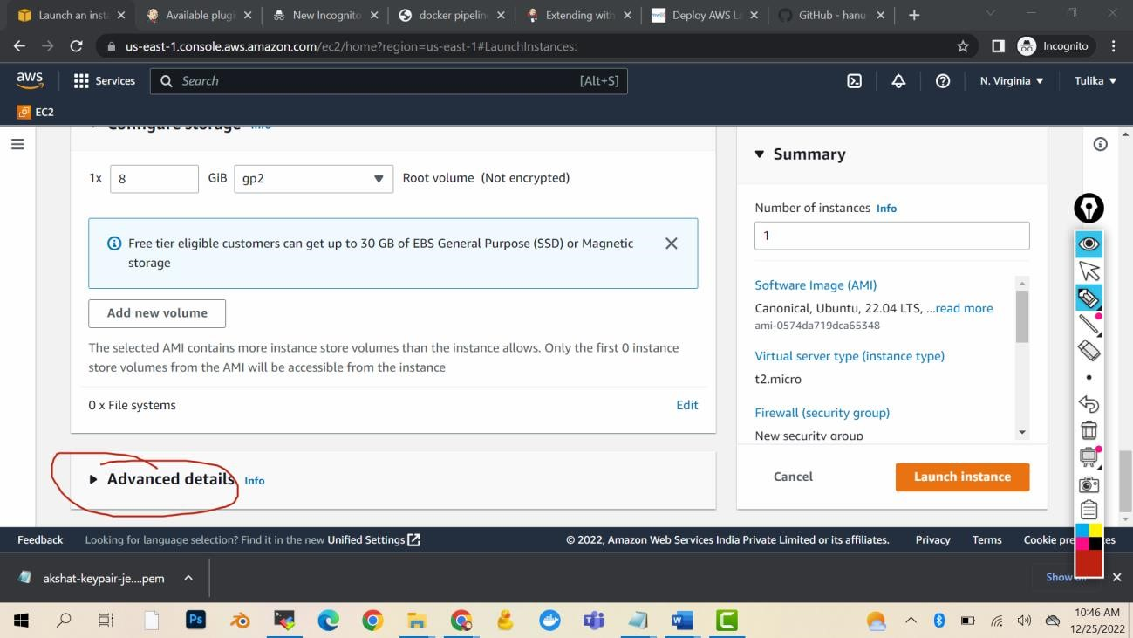

Launch instance

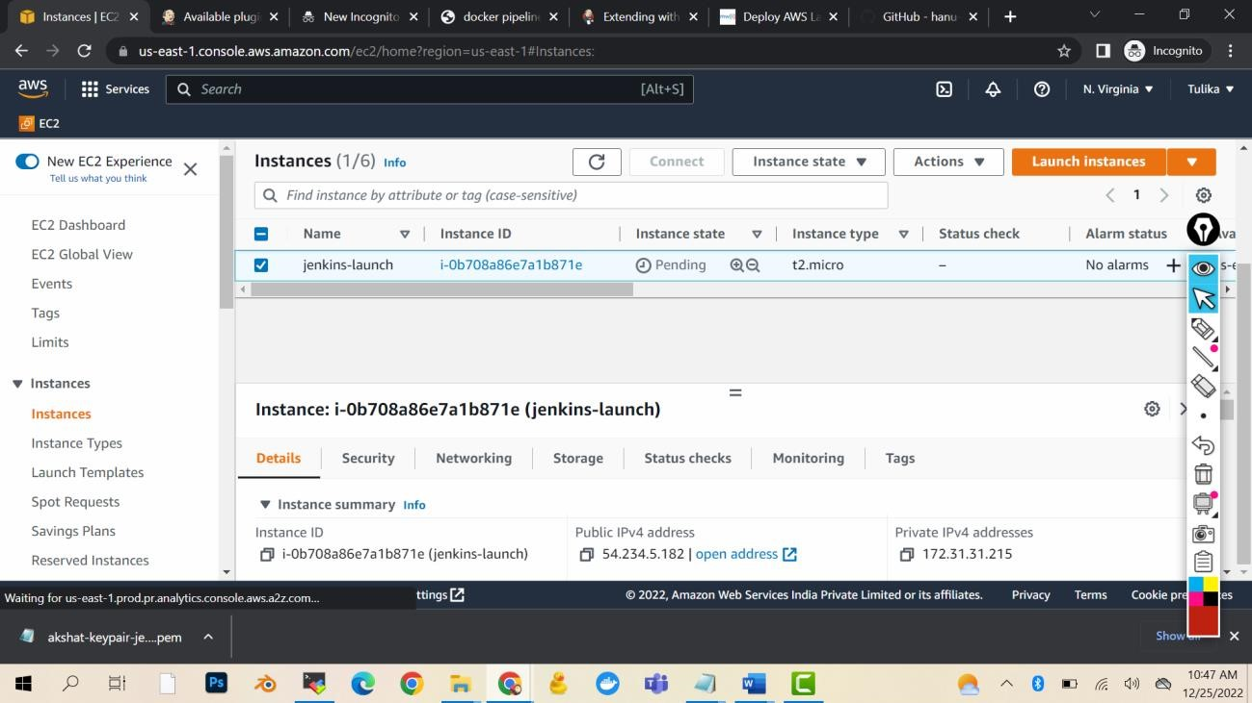

Wait for the Jenkins to launch

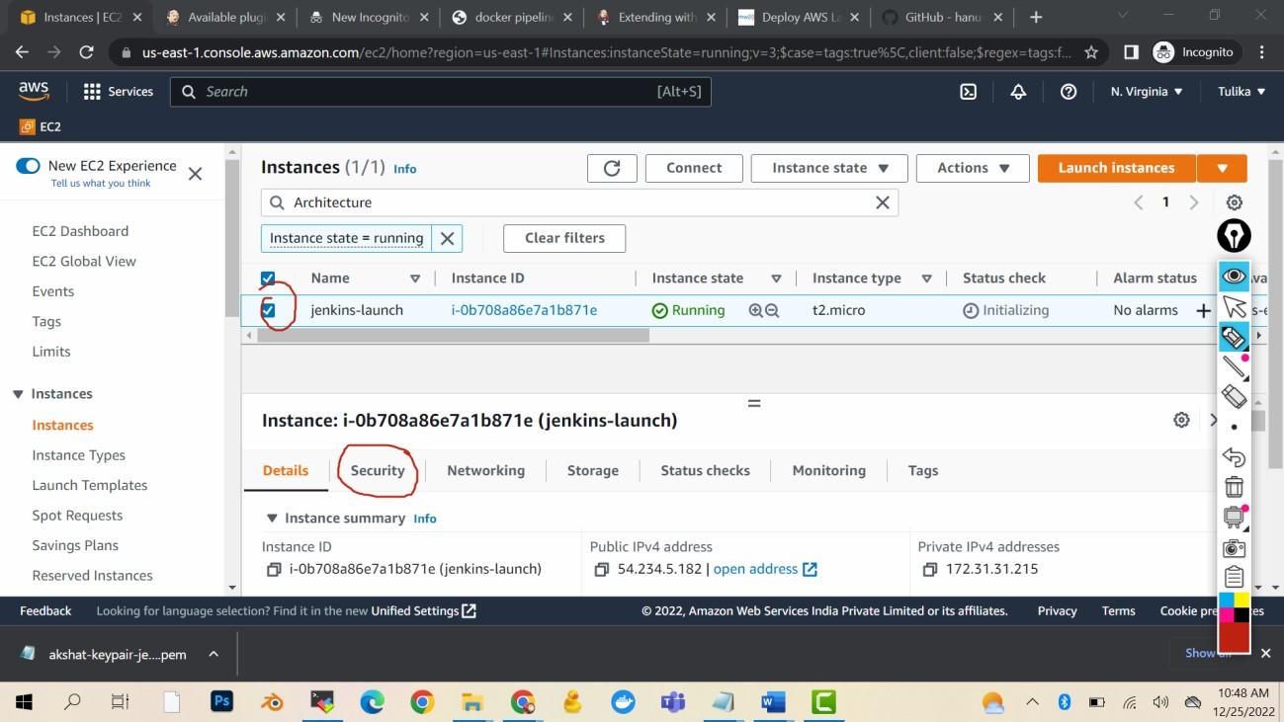

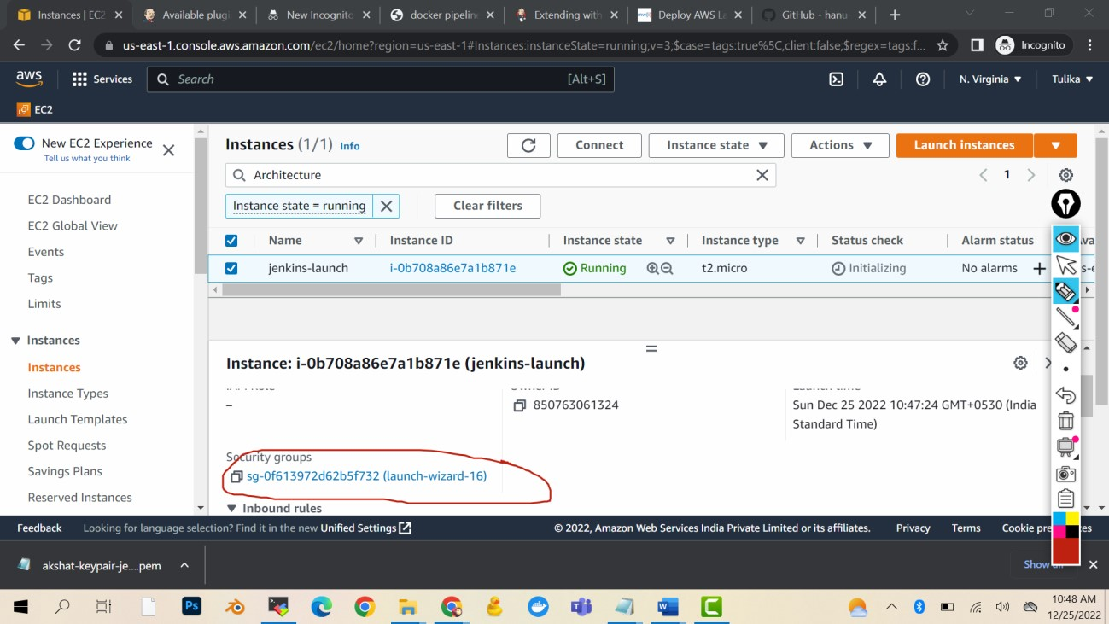

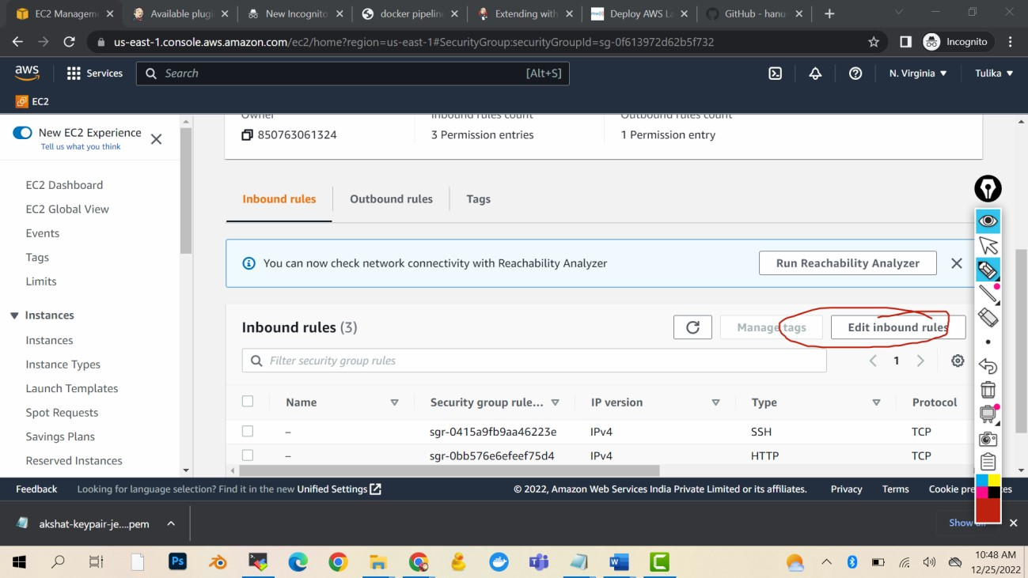

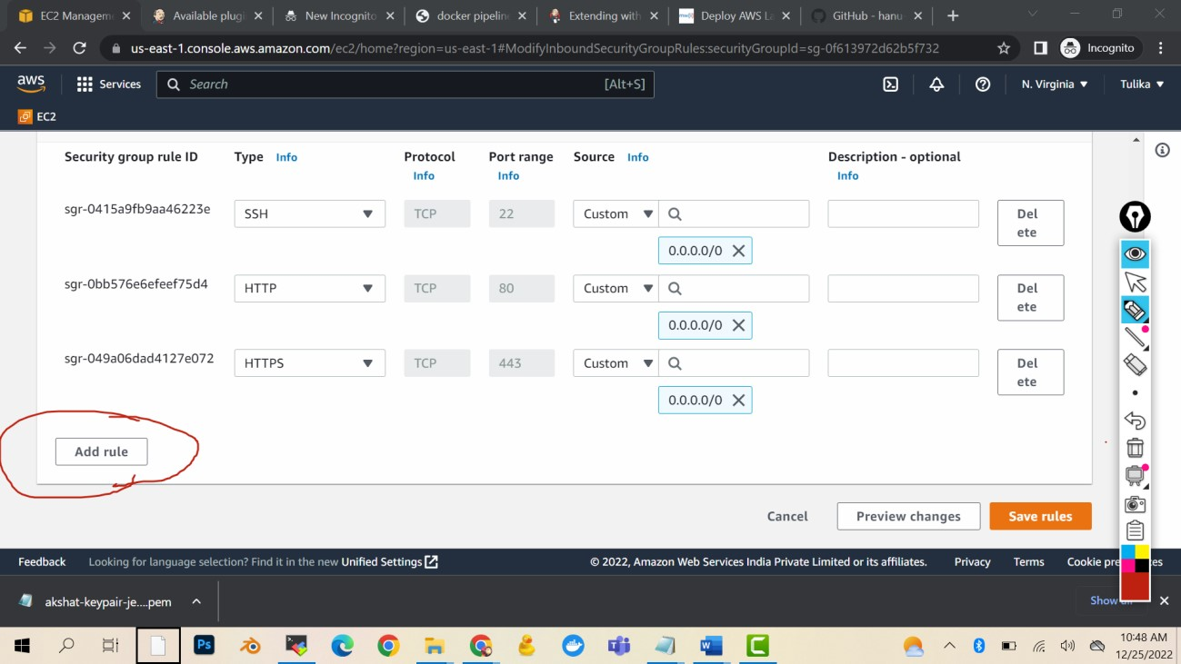

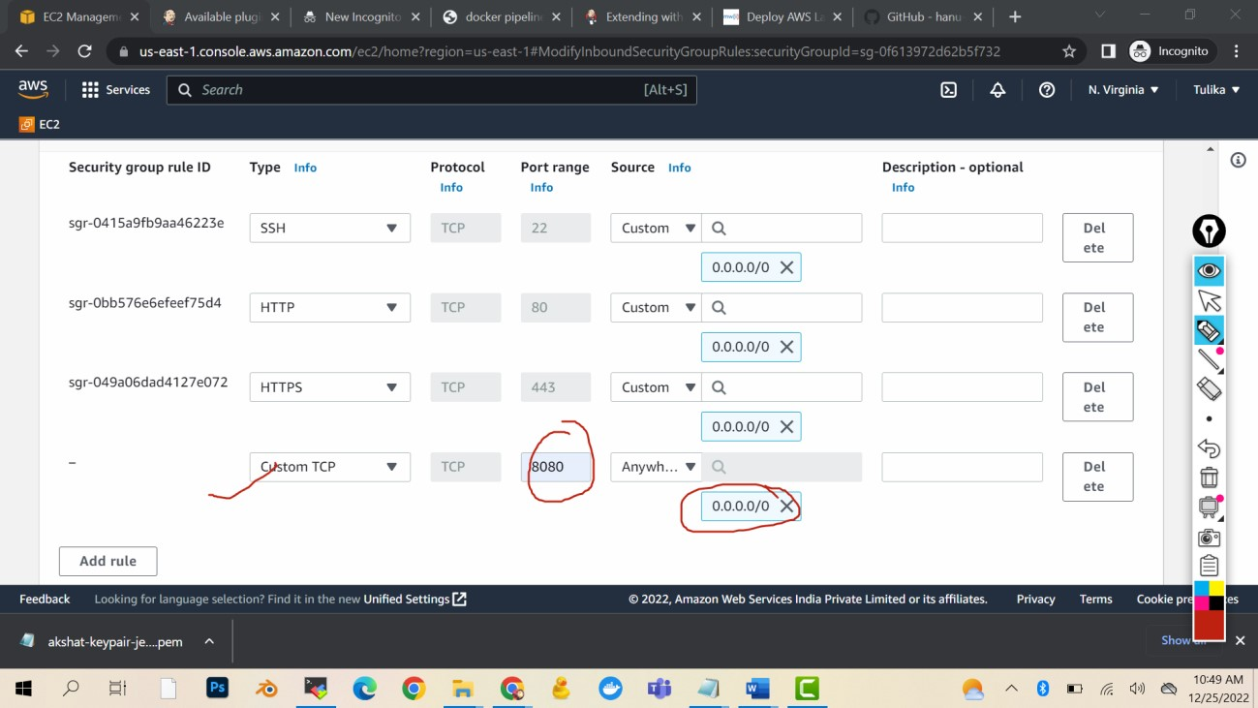

Save

Login in the machine

# Command for installing Java 11 sudo apt-get update -y

sudo apt-get install default-jdk - y

# Command for installing maven sudo apt-get install maven -y

# Script for Jenkins installation

This is the Debian package repository of Jenkins to automate installation and upgrade. To use this repository, first add the key to your system:

curl -fsSL <https://pkg.jenkins.io/debian-stable/jenkins.io-2023.key> | sudo tee \

/usr/share/keyrings/jenkins-keyring.asc > /dev/null

Then add a Jenkins apt repository entry:

echo deb [signed-by=/usr/share/keyrings/jenkins-keyring.asc] \

https://pkg.jenkins.io/debian-stable binary/ | sudo tee \

/etc/apt/sources.list.d/jenkins.list > /dev/null

Update your local package index, then finally install Jenkins:

sudo apt-get update

sudo apt-get install Jenkins -y

service jenkins start

Now copy public ip and paste it in the browser

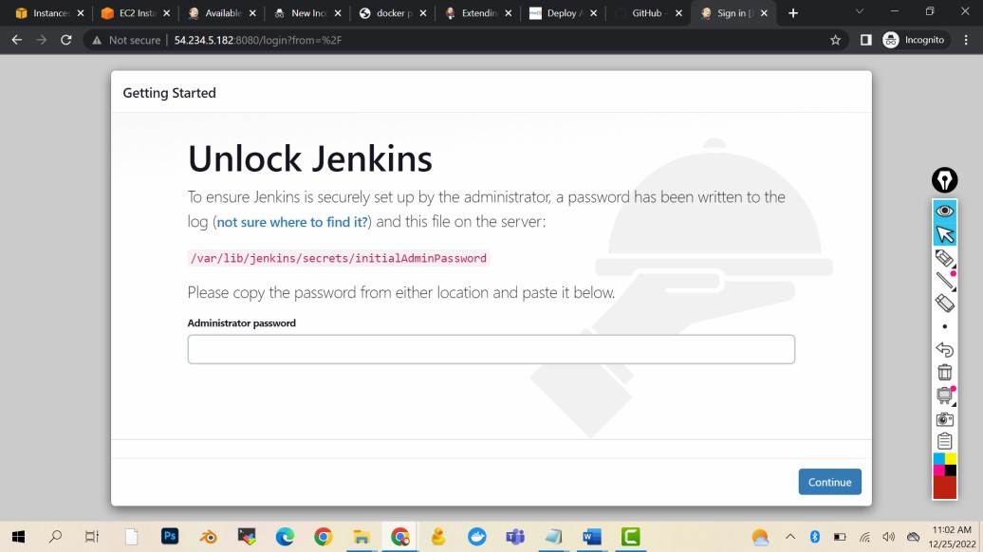

cat /var/lib/jenkins/secrets/initialAdminPassword

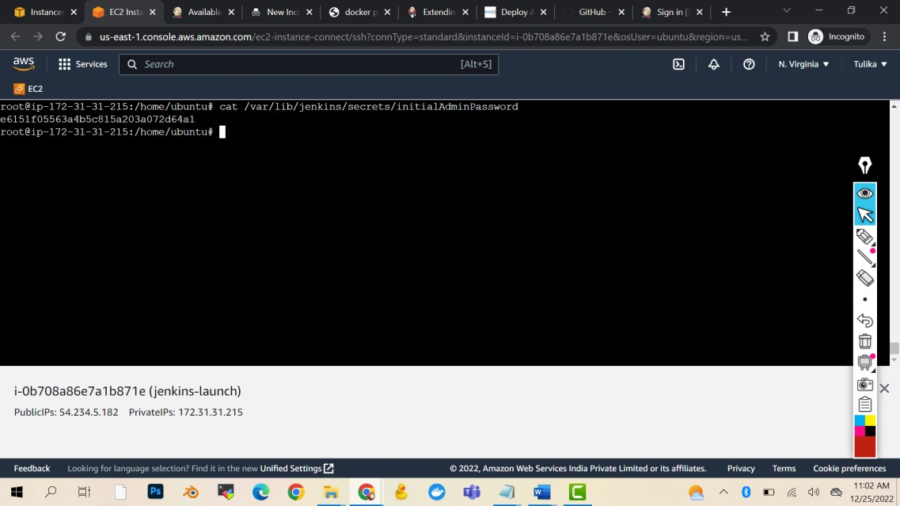

Copy the pass and paste in the browser

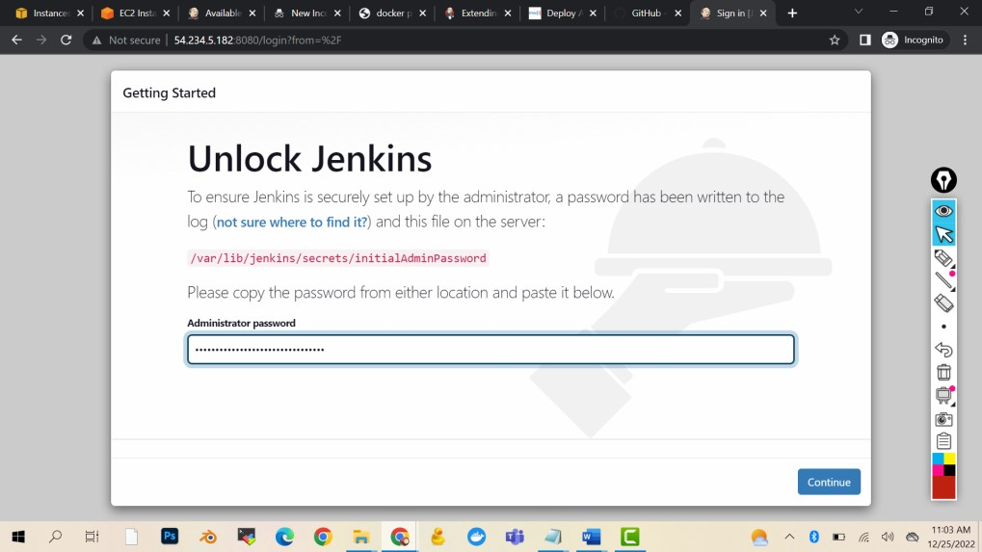

Continue

Install suggested plugins

Username: admin

Pass: admin

Full name: Parwez Aamir

Email: admin@gmail.com

Save and finish

Start using Jenkins